GFWC General Federation of Women’s Clubs
CFWC California Federation of Women’s Clubs

HEMET WOMAN’S CLUB
Application for Membership

NAME____________________________________________________________________________

Spouse/Other _____________________________________________________________________

Address___________________________________________________________________________

Phone(Home)__________________________________ Cell____________________________

Birthday_____________________Email address_________________________________________

Membership Requirements

- Attend two business meetings and/or have existing member recommendation before submitting membership application.
2. Comply with Club’s ByLaws and Standing Rules
3. Assist with at least one yearly fundraising event
4. Attend New Member Orientation
5. Allow use of your photo to be taken for all newspaper articles, website and Facebook
postings including club newsletters, to promote club activities

Membership Dues and Fees

New Members: $40 + initiation fee $5 = $45 (Jan-Sept)
$15 + initiation fee $5 = $20 (Oct-Dec)

Annual renewal Dues $40 payable January and no later than March HWC general meeting

Miscellaneous Membership Fees

HWC Name Badge=member pays current fee
HWC Shirt Bling Design + shipping= member pays current fee
(Member provides own shirt)

Signature__________________________________________________Date:_______________

Please be sure to turn over and complete questionnaire
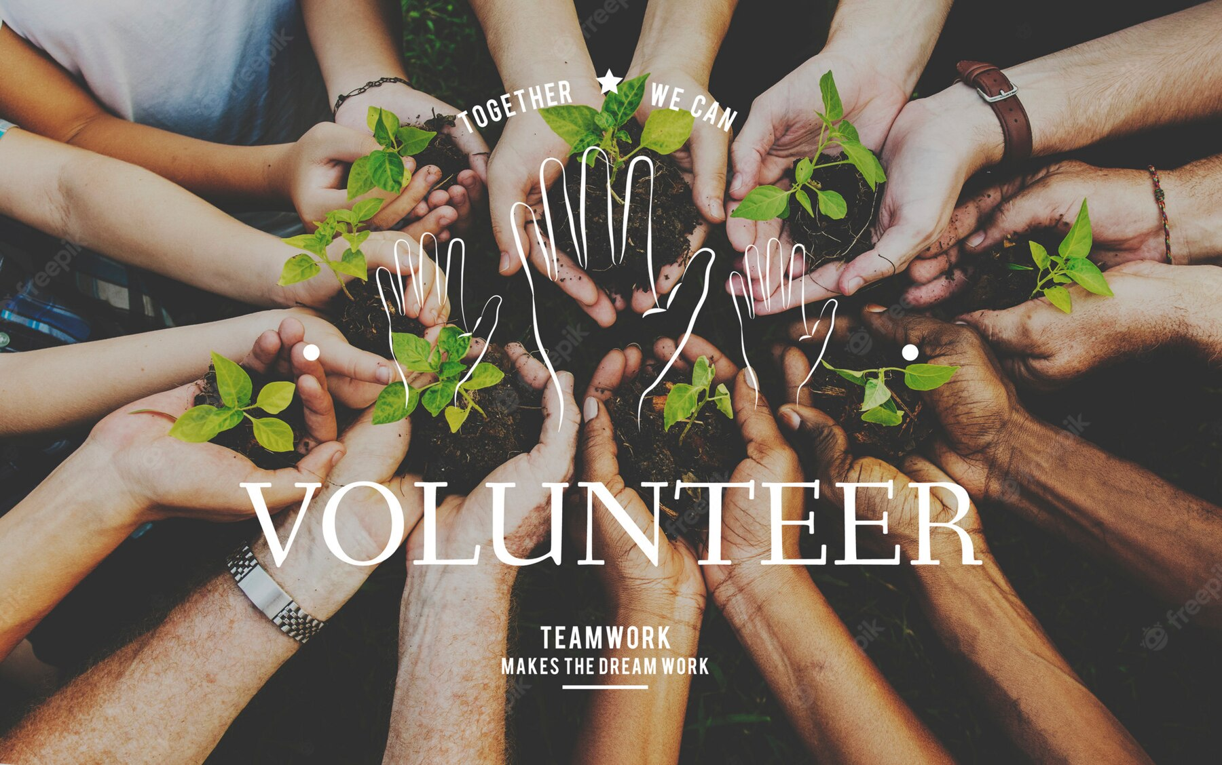

Please complete this page so that we may get better acquainted with you.

- What brought you to the Hemet Woman’s Club (HWC?)

b. My charitable areas of interest in the community are:

c. My Talents/training/computer skills include:

d. My leisure activities and interests are

e. If someone referred you to our club, please note their name
here:

Please return this completed application with fees to Hemet Woman’s club Financial Secretary, PO Box 635 Hemet, Ca 92546

You can visit us on Facebook, cfwc-hemetwomansclub.org. or contact us at hemetwomansclub@gmail.com

