GFWC International Federation of Women's Club
CFWC California Federation of Women’s Clubs

Hemet Woman’s Club

Application for Membership
2020-2022

Please print in space provided:

Name ______________________________ Spouse/Other ________________

Address ______________________________ City ____________Zip __________

Phone(s) _____________________________ Cell _________________________

Email _____________________________ DOB ________________________

You attend at least two business meetings and/or have a member recommendation before submitting this membership application. A verifiable address, phone number and e-mail (if applicable) must be provided when being considered for membership.

Membership Requirements
- Comply with Club’s By Laws and Standing Rules
- Participate in one federated or standing committee
- Assist with one fundraising event
- Must attend New Member Orientation
- Annual Initiation of New Members in the Spring

Membership Dues and Fees
New Members: $40 Annual Dues + $5 Initiation Fee = $45 (June-Sept)
New Members: $15 Pro-rated + $5 Initiation Fee = $20 (Oct-Dec)
Renewal: $40 annual dues payable January 1 and no later than the
March meeting to HWC

Please return this completed application to Hemet Woman’s Club,
Financial Secretary, PO Box 635, Hemet, CA 92546-0635.

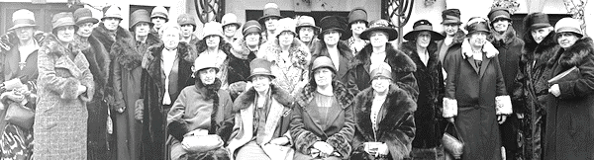

Please complete this page so that we may get better acquainted with you.

- What brought you to Hemet Woman’s Club (HWC)?

- My charitable areas of interest in the community are:

- My talents and/or training include:

- My leisure activities and interests are:

- If someone referred you to our club, please note their name below:

You can visit us on Facebook, CFWC-hemetwomansclub.org. or contact us at HemetWomansClub@gmail.com

